API SETUP
1. first go to amazon api gateway and create api
2. finally routes shd be like
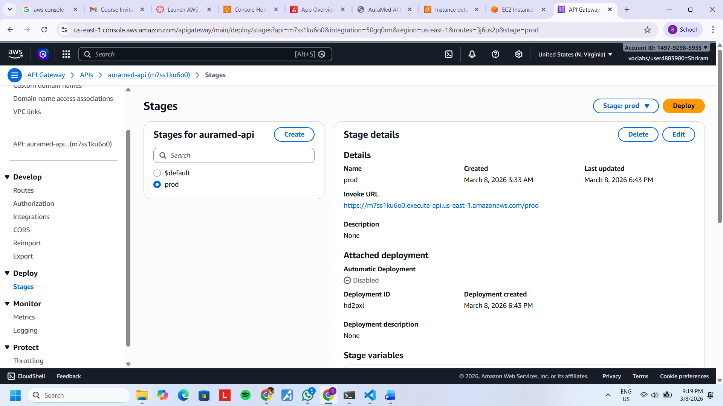
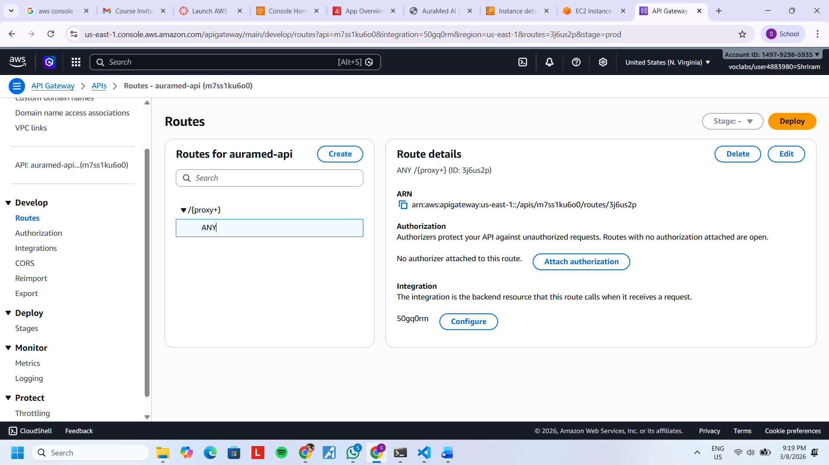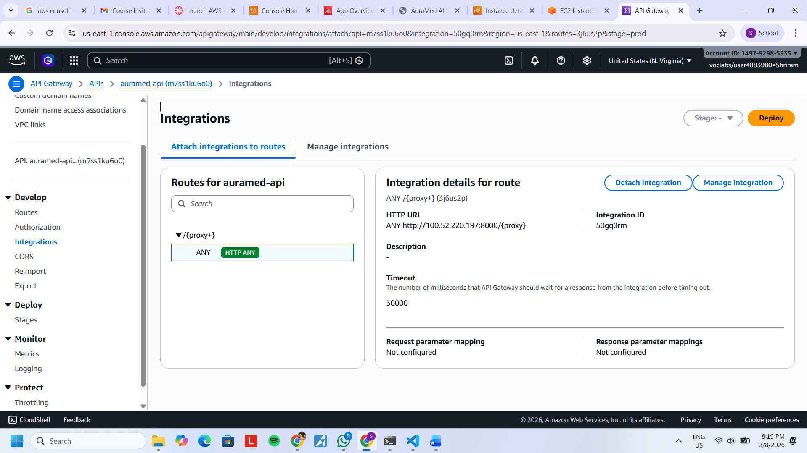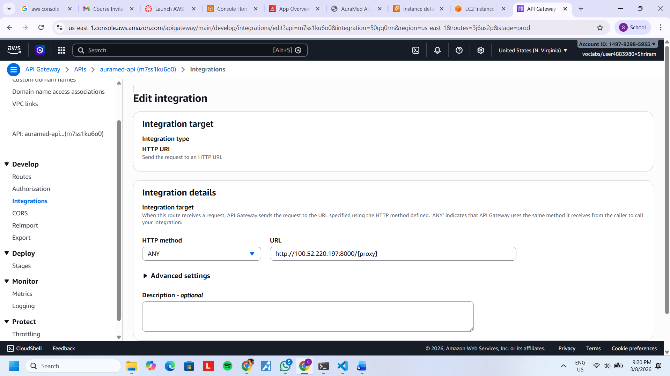
3. in the image-- http://(100….)/{proxy} --- in brackets ()- shd put ur backend public ip

